Unit 4 |  | HAPPY FACES
hair  [heə] |  |  | 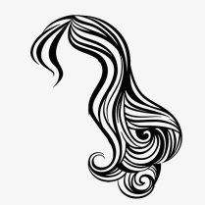
eyes  [ájz] |  |  | 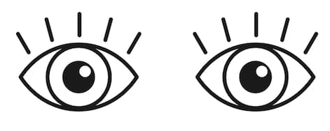
face  [fejs] |  |  | 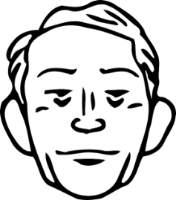  obličej
nose  [nouz] |  |  | 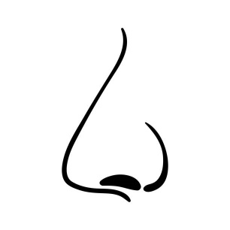
ears  [ɪəz] |  |  | 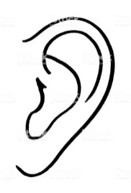  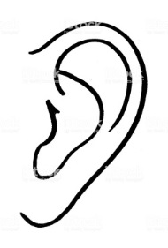
mouth  [mauf] |  | 